

Wanniassa School
  - Report of Review
Student-Centred Improvement Framework

ACT Education Directorate
Insert Directorate

Student-Centred Improvement Review Details
Review date | 12 August 2025
Principal | Kate Marshall
Current improvement priorities | Increase growth in writing across all year levels  Increase growth in numeracy across all year levels
Report date | 20 August 2025
Review team | Lead reviewer: Kim McCormack, Principal in Residence, Student-Centred Improvement and Leadership  Executive Education Leader: Steve Collins  Co-reviewers: Andrew Buesnel, Principal in Residence, Student-Centred Improvement and Leadership  Peter Radford, Principal, Mount Stromlo High School  Jacqueline Chapman, Principal, Arawang Primary School Julie Dixon, Principal, Caroline Chisholm School
People spoken to | Staff: 72  Students: 60  Community consultation in conjunction with evidence from Annual Satisfaction and Climate Survey.

Pre-review visit
On 25 June 2025, the review team conducted a pre-review visit at Wanniassa School. The length, format, and lines of inquiry of the external review were based upon evidence collected through school self-evaluation, learning walkthroughs across the school, and discussions with students, staff, and the leadership team. The following Dimensions and Elements were selected as focus areas by the school following self-evaluation:
Dimension | Element
Leading | Collaborative culture
Learning | Pedagogy
Wellbeing | Belonging

Overview of the Student-Centred Improvement Framework
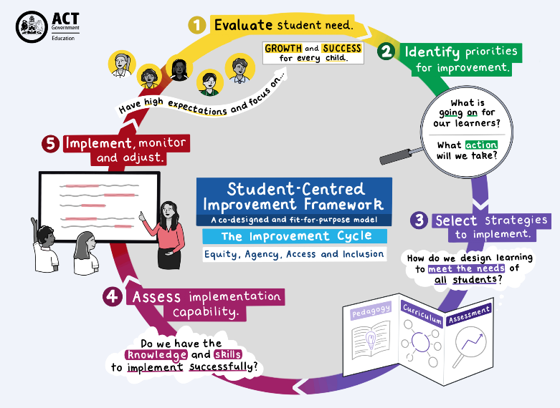
The new fit-for-purpose Student-Centred Improvement Framework (SCIF) places students at the centre of school improvement cycles, answering what works for whom, under what circumstances and why, through self-evaluative internal review led by effective and targeted use of data and spirals of inquiry, cross-system collaboration, strategic alignment, and external review. School self-evaluation and external review are complementary processes, both focused on improvement. The school self-evaluation process gives schools a means of identifying and addressing priorities, and of ensuring a whole-school focus on improving specific aspects of teaching and learning. Schools undergo a standard external school review every three to five years, with most undertaking one every four years. The reviews are supplemented by annual student-centred improvement visits and a pre-review visit.
The external review team consists of:
- a principal within the Student-Centred Improvement and Leadership (SCl&L) team
- an ACT public school principal external to the school under review
- Executive Education Leader for the network of the school under review
- an additional external principal may be engaged for schools with over 700 students.
Through the lens of the Student-Centred Improvement Evaluation Tools, co-designed by ACT public education principals, the review team consider multiple sources of evidence provided by the school alongside the evidence gathered through conversations with staff, students, parents, and community members.
The Evaluation Tools are foundational to the improvement cycle, building the processes and practices for sustained positive impact. They are framed by three dimensions ‘Learning’, ‘Leading’ and ‘Wellbeing’ across which schools need to demonstrate improvement. All three are interlinked, with evidence sources and improvement actions likely to impact multiple dimensions over the course of an improvement cycle. Schools will identify elements within these dimensions to target their improvement actions.
Following the self-evaluation and external review, the school receives an internal planning report, outlining key findings against the Student-Centred Improvement Evaluation Tools, and Recommended next steps to support the development of their next School Strategic Plan.
Student-Centred Improvement and Leadership Team

Dimension: Leading
Leading for school improvement empowers inquiry, effective practices and collaboration via a strategic vision that centres the school’s values and aspirations as well as perspectives of students, families, teachers, and the wider community. Leaders promote a vision for teaching and learning that is inclusive and values student participation and voice. School improvement is fostered in environments ready for change, in cultures of high expectation and mutual trust, and where staff and students are resourced appropriately to perform at their best.
Element: Collaborative culture
Lines of Inquiry
These were co-designed by the review team and school leadership team following the Pre-Review Visit.
1. How do collaborative practices at Wanniassa School impact student learning outcomes?

Findings
- Students, teachers, leaders, support staff and parents spoke of a strong sense of community. In addition, students and parents spoke positively about the responsive, caring nature of whole school team.
- School leaders foster a strong culture of collegiality and trust among staff, which is supported by evidence in the Annual Satisfaction and Climate Survey.
- Teachers, leaders, and support staff acknowledged improvements in school culture over the past few years. This is supported by improved Annual Satisfaction and Climate Survey data, particularly in Academic Emphasis and Wellbeing.
- Students spoke about strong relationships with teachers, leaders and LSAs with a sense of adults working hard to meet their needs.
- Teachers and leaders acknowledged Professional Learning Communities (PLCs) are in the early stages of maturity. There is a strong desire to build on existing processes and practices to ensure greater consistency and a focus on improving student outcomes. Evidence provided to the review team supported a renewed focus on a shared understanding of the purpose of PLCs.
- Teachers expressed a desire to develop a deeper understanding of the rationale informing school priorities and how they link together to improve student learning outcomes.
- There is a strong appetite from teachers for greater clarity and shared awareness of professional expectations associated with school-wide roles and responsibilities.
- P-6 teachers and leaders appreciated working together in a team-teaching environment, including sharing planning and preparation and facilitating a collaborative working environment.
- Teachers and LSAs communicated the desire for constructive feedback aimed at improving their practice and ability to meet students at their point of need.

Dimension: Learning
Learning is deeper than the simple acquisition of new understandings, information, knowledge and skills. Learning is fostered in environments of high motivation, engagement and authenticity, enculturating high expectations and reflection, embracing diversity to meet student need. Curriculum and assessment must adhere to obligated standards yet be flexible and targeted enough to uphold the moral imperative of optimising outcomes for all.
Element: Pedagogy
Lines of Inquiry
These were co-designed by the review team and school leadership team following the Pre-Review Visit.
- How do current teaching and learning practices support a culture of engagement and high expectations for all students?

Findings
- Teachers and leaders described the need for an agreed pedagogical approach to facilitate consistent and improved practice across the school with a focus on catering to the diverse needs of students.
- Teachers and leaders described engagement in PLCs with variation in how student data informs teaching. PLCs provide time for teachers to discuss the learning needs of their students.
- Teachers and leaders spoke about variability across teams in curriculum, pedagogy, and assessment practices. The development of Common Formative Assessments has had a positive impact in developing a shared focus for teachers on the senior campus.
- The review team saw, heard and were provided evidence of various strategies to meet the diverse needs of learners and a willingness to broaden staff pedagogical skills, particularly in differentiation. Learner Profiles are used by some staff to enhance participation and engagement in learning through an understanding of individual student learning and wellbeing needs.
- Student survey data and conversations with students indicate that the whole staff team have high expectations and support students in engaging with challenging academic work.

Dimension: Wellbeing
Wellbeing for learning encompasses a student’s physical, mental, emotional and social health at school. Wellbeing is fostered within effective learning cultures where students encounter powerful relevant learning, in safe and accessible environments that cultivate belonging, and where there are positive connections between the purpose of students, their educators, their school and the school community.
Element: Belonging
Lines of Inquiry
These were co-designed by the review team and school leadership team following the Pre-Review Visit.
- How do whole school approaches support belonging, safe and inclusive learning environments?
Findings
- The review team observed settled, calm, and engaged learning environments on each campus.
- Teachers, leaders, support staff and students reported positive and caring relationships, with a strong sense of belonging to the Wanniassa School community. On the junior campus, staff reflected on the benefits of Positive Behaviour for Learning (PBL) and the Berry Street Education Model (BSEM) in supporting wellbeing and strengthening relationships with students.
- Teachers, leaders and LSAs acknowledge the benefits of explicitly linking the work of PBL and BSEM to enhance the wellbeing outcomes for students.
- Cultural Integrity begins at Koori Preschool and continues through other specific initiatives, including Yarning Circles and the Deadly Kids Club on the junior campus. Teachers, leaders and LSAs have identified a desire for a shared understanding of what Cultural Integrity means at Wanniassa School.
- Teachers, leaders and LSAs identified potential opportunities to strengthen inclusive practices and build capability in supporting the learning needs of all students to assist in strengthening a safe and inclusive learning environment.
- Learning Support Assistants (LSAs) expressed a desire for further training opportunities to assist students with complex needs.
Recommended next steps
- Co-design a clear and focused pedagogical approach for Wanniassa School that aligns curriculum and assessment practices.
- Continue to develop and implement a clear, staged plan to strengthen PLCs to establish consistent structures, processes and a shared focus on using evidence to improve outcomes for all students.
- Establish a structured process for staff to receive regular feedback on their practice through targeted observation, coaching, and mentoring.
- Enhance opportunities for students to have agency and voice to strengthen engagement and ownership in their learning and school culture.

